

**SUBMITTED BY- SUBMITTED TO-**

**PRASHANT KUMAR SINGH SOURABH JAIN SIR**

**BRANCH - COMPUTER SCIENCE**

**ROLL NUMBER - 12111019**

**MOBILE – 6394287313**

**Assignment - 3**

1 - Write a program to compare two strings without using strcmp() function.

#include <stdio.h>

int compare(char[],char[]);

int main()

{

char str1[20];

char str2[20];

printf("Enter the first string : ");

scanf("%s",str1);

printf("Enter the second string : ");

scanf("%s",str2);

int c= compare(str1,str2);

if(c==0)

printf("strings are same");

else

printf("strings are not same");

return 0;

}

int compare(char a[],char b[])

{

int flag=0,i=0;

while(a[i]!='\0' &&b[i]!='\0')

{

if(a[i]!=b[i])

{

flag=1;

break;

}

i++;

}

if(flag==0)

return 0;

else

return 1;

}

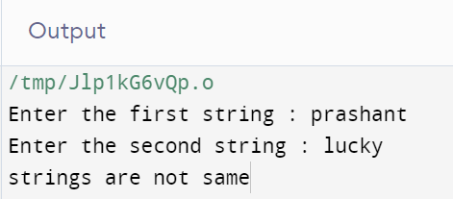

2 - Write a program for finding Substring from given string.

#include <stdio.h>

#include <string.h>

char *getSubString(char *inputStringLength, char *subString,

int index, int subStringLength);

int main()

{

char inputString[100], subString[100];

int index, subStringLength;

printf("Enter a String \n");

gets(inputString);

printf("Enter starting position of sub-string and it's length \n");

scanf("%d %d", &index, &subStringLength);

printf("SubString is : %s \n", getSubString(inputString,

subString, index, subStringLength));

return 0;

}

char *getSubString(char *inputString, char *subString,

int index, int subStringLength)

{

int i, inputStringLength = strlen(inputString);

if (index < 0 || index > inputStringLength ||

(index + subStringLength) > inputStringLength)

{

printf("Invalid Input");

return NULL;

}

for (i = 0; i < subStringLength; i++)

{

subString[i] = inputString[index++];

}

subString[i] = '\0';

return subString;

}

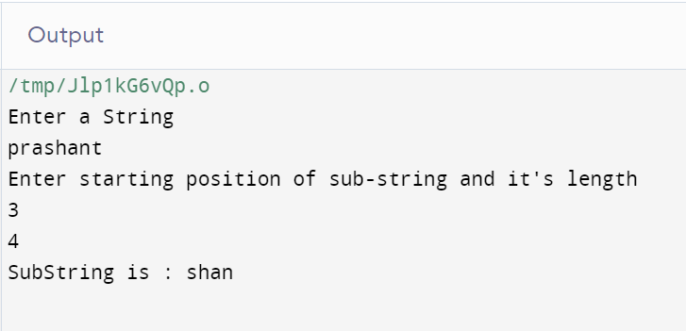

3 - Write a program to reverse a string.

#include <stdio.h>

#include <string.h>

int main()

{

char Str[100], RevStr[100];

int i, j, len;

printf("\n Please Enter any Text : ");

gets(Str);

j = 0;

len = strlen(Str);

for (i = len - 1; i >= 0; i--)

{

RevStr[j++] = Str[i];

}

RevStr[i] = '\0';

printf("\n And the Result of It is = %s", RevStr);

return 0;

}

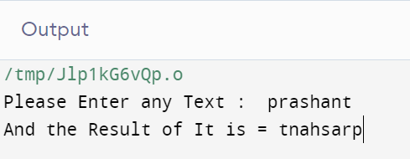

4 - Write a program for changing Uppercase to Lowercase and vice versa of

string.

#include <stdio.h>

int main()

{

char str[20];

int i;

int len = 0;

printf("\n\nEnter The String: ");

scanf("%s", str);

// Calculating length of input string

while (str[len] != '\0')

{

len++;

}

for (i = 0; i < len; i++)

{

if (str[i] >= 65 && str[i] <= 90)

{

str[i] = str[i] + 32;

}

else if (str[i] >= 97 && str[i] <= 122)

{

str[i] = str[i] - 32;

}

}

printf("\nConverted String(Lower/Upper) Is: %s\n", str);

return 0;

}

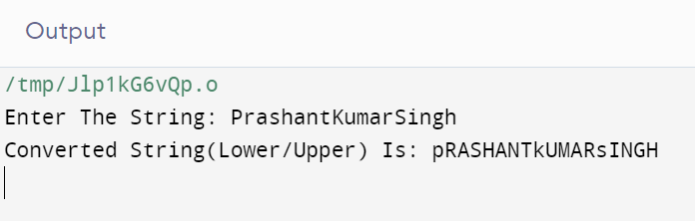

5 - Write a program for connecting two strings (Without using string library

function).

#include <stdio.h>

#include <string.h>

void concat(char[], char[]);

int main()

{

char s1[50], s2[30];

printf("\nEnter String 1 :");

gets(s1);

printf("\nEnter String 2 :");

gets(s2);

concat(s1, s2);

printf("nConcated string is :%s", s1);

return (0);

}

void concat(char s1[], char s2[])

{

int i, j;

i = strlen(s1);

for (j = 0; s2[j] != '\0'; i++, j++)

{

s1[i] = s2[j];

}

s1[i] = '\0';

}

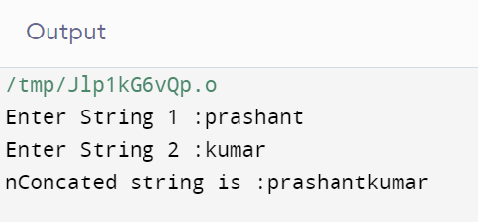

6 - Write a program for copying a String into another upto n elements

(Without using string library function).

#include <stdio.h>

#include <string.h>

int main()

{

char Str[100], CopyStr[100];

int i, a;

printf("\n Please Enter any String : ");

gets(Str);

printf("\n Enter the number of elements upto which u want to copy : \n");

scanf("%d", &a);

for (i = 0; i < a; i++)

{

CopyStr[i] = Str[i];

}

CopyStr[i] = '\0';

printf("\n String that we coped into CopyStr = %s", CopyStr);

printf("\n Total Number of Characters that we copied = %d\n", i);

return 0;

}

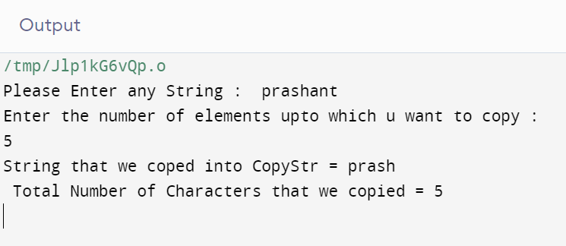

7 - Write a program to find the length of a string without using string library

function.

#include <stdio.h>

int main()

{

char str[100];

int length;

printf("\nEnter the String : ");

gets(str);

length = 0;

while (str[length] != '\0')

length++;

printf("\nLength of the String is : %d", length);

return (0);

}

